

**Blood Bank Management System** CSE3002 Internet and Web Programming J Component Report

Fall 2022-23

# Team Members

1.Preeti Poddar (20BCE0905) 2.Diksha Adhikari (20BCE2770) 3.Viresh Jagadinni(20BCI0292)

# Video Link

[https://drive.google.com/file/d/1AgCjjPseDCK0MGNNCceHnRVD8480Na_n/vie](https://drive.google.com/file/d/1AgCjjPseDCK0MGNNCceHnRVD8480Na_n/view) [w](https://drive.google.com/file/d/1AgCjjPseDCK0MGNNCceHnRVD8480Na_n/view)

**Under the Guidance of** Dr. Lydia Jane G **SCOPE**

# Abstract

The project is dedicated to developing an online Blood Bank Management System. The process of managing blood banks, donors and recipients of blood requires proper and systematic management, since it is a very important process which could save the lives of hundreds of people. The purpose of this project was to develop a blood management system which facilitates the management of blood donor information and the distribution of blood in various parts of the country. Without quick and immediate access to donor records, creating market strategies for blood donation and sensitization of blood donors becomes quite difficult. The blood bank management system offers features to quickly access the donor records collected from several parts of the country. It allows monitoring of the results and the blood donation activity such that relevant objectives of the organization can be checked. The website assists the people who are in need of blood by giving them details of blood group availability or regarding the donors with the same blood group living in the same city or area. They do not need to go anywhere to search for blood when they need it. They just need to use this website and all the results will appear in just a second. By using the Blood Bank website, we can find hundreds of people who are donating blood and also view the details of those people, which city they belong to and their blood group. Therefore, the online blood bank management system is a more efficient and reliable method to manage blood bank records, than the traditional manual system of management.

# Introduction

The goal of this project is to create an online resource for blood donation information. The distributed client-server computing technology has been taken into consideration throughout the development of the entire project.

The blood donation agent is responsible for compiling e-Information about the donor and any organisations connected to blood donation. Any individual who is interested in donating blood can register through this application, and any organisation that wishes to register on this website can also do so. Additionally, this website can be used by any common consumer who wishes to request blood online.

# Architecture

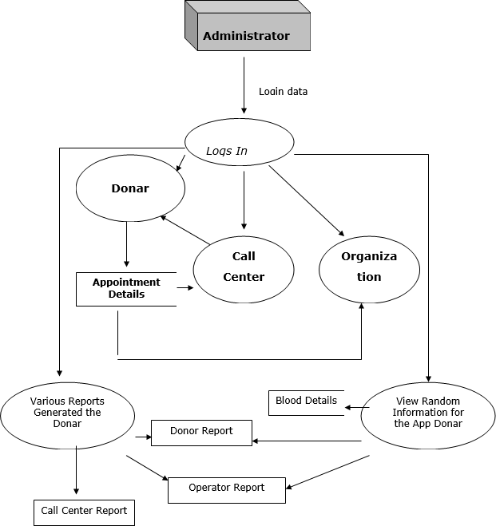

## Use Cases of Blood Donation Agent Interface

### Use case For Admin Module

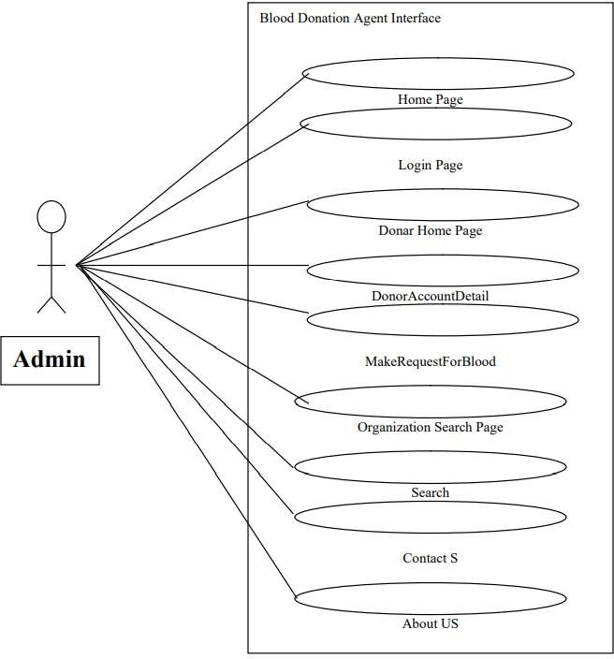

**Use case For Donor Module**

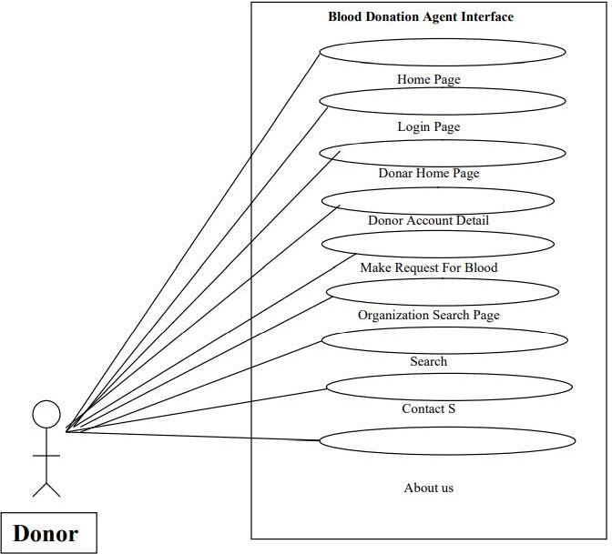

# Literature Study

Study of similar systems that are currently available. Features that are missing in the current system and that you have addressed in your system.

|  |  |  |  |
| --- | --- | --- | --- |
| Title (study) | Methodology used/ Implementation | Limitatio ns/ Future Research  / Gaps identified | Advantages |
| 1.Development of a Blood Bank Management System | Methodology that has been chose to develop BBMS is the Rational Unified process  (RUP) from Noushin Ashrafi, & Hessam Ashrafi and Rational Unified Process at  [www.ibm.com/develo](http://www.ibm.com/develo) perworks/rational/.../1 251_bestpractices | However, this blood bank does not provide any facility for the donor and the patient.  Therefore, they  cannot know how many times that they have donated their blood. As for the donor, they cannot know their blood screening result for  each time they donate their blood | tem that is developed to manage blood bank in HSNZBBMS is a management sys |
| 2. Research Paper on Blood Bank Donation and Management using Danjgo | When the user is seeking for donor he has to register in user registration form and then login in as user. In order to search for donor add blood group and address in search engine. The backend algorithm of search engine searches the database, sorts them and shows them in a table shown in table . The result is sorted on the basis of most eligibility  according to the  recruitment algorithm | One of the disadvantages identified was the blood bank staff should enter the details of the donor at any time that gives blood In which he led to duplication of donors and data data, they may also be lost | This study has developed an online platform which has made the blood  receivers to connect with donors at the place of requirement this application can be developed more by using machine learning and artificial intelligence and also by adding GPS technology. |

|  |  |  |  |
| --- | --- | --- | --- |
| 3.Computerized  central blood bank management system | Designed using php language andd microsoft my sql database | Problem that led to design this system which in turn led to human errors is that information | System save all donor records,blood information,testing  results |
| 4.online blood bank system using android | Two phases:  User registration Request blood | Due to lack of  connectivity these services cant reach the  agricultural,village areas | Helps to avoid  wasting time to visit hospitals |
| 5.study on blood bank management system | It consists login page and will register to donate the blood | Takes time | Help to easily access to rare bloodgroups |
| 6.cloud based online blood bank management system | Creation of account | It is less effective to villagers | Protect the data and package from  accidental of deliberate threats |
| 7.efficient facial expression  recognition algorithm based on hierarchical deep neural network | FER algorithm AUs using LBP | Lack of accuracy | We wil describe the some of the recent  algorithms involving the appearance of  feature extraction method |

# System Requirements

### HARDWARE REQUIREMENTS:

* PIV 2.8 GHz Processor and Above
* RAM 512MB and Above
* HDD 20 GB Hard Disk Space and Above

### SOFTWARE REQUIREMENTS:

* WINDOWS OS (XP / 2000 / 200 Server / 2003 Server)
* Visual Studio .Net 2005 Enterprise Edition
* Internet Information Server 5.0 (IIS)
* Visual Studio .Net Framework (Minimal for Deployment)
* SQL Server 2000 Enterprise Edition

# Modules

## The modules involved are:

### Administration:

In this module the Administrator has the privileges to add all the Blood Groups, Blood Type, Organization, Type, Country, State, City, and Location. He can search all the info about the Organization, Donor.

### User Account:

* + - AccountID
    - Username
    - Password
    - UserDesc
    - HintQuestion
    - Answer
    - RoleID
    - Active

### Functionality

* + - * Association User Account with UserRole.
      * Association User Account with Organisation.
      * Association User Account with personal Details.
      * Association User Account with Employee deatails.
      * Association User Account with BloodDonation Details.

### Alerts:

* All fields are mandatory
* Select user role
* Select role id
* Select role name

### UserRole:

* RoleID
* RoleName
* RoleDesc
* Active

### Functionality:

* Association user role with user Account

### Alerts:

* Select Role Id
* Select role name

### City:

* + CityID
  + CityName
  + CityDesc
  + CityCode
  + StateID
  + Active

### Functionality:

* + Association Location with city
  + Assocition Address with city.

### Alerts:

* + - Select cityId
    - Select cityNane
    - Select state code

### BloodGroup:

* + - * BloodGroupID
      * BloodGroup
      * Description
      * Active

### Functionality:

* + - * + Association Blood group with Personal details.

### Alerts:

Select BloodGroupID

Select BloodGroupID

### Blood Type:

* + - BloodTypeID
    - TypeName
    - TypeDesc
    - Active

### Functionality:

* + - Association Blood type with Personal details.

### Alerts:

* + - * Select BloodGroupID
      * Select TypeName

### Personal Details:

* + - UserAccountID
    - FirstName
    - MiddleName
    - LastName
    - Email
    - DOB
    - Weight
    - Gender
    - ImageURL
    - BloodGroupID
    - BloodType
    - BloodType
    - AddressID
    - ContactNo_Office
    - ContactNo_Residence
    - MobileNo
    - Active

### Functionality:

* + - * Association personal detaials with preferd location Day Time Details.

### Alerts:

* + - * + Select user account id
        + Select Email id
        + Select date of birth

In this module all the employee who has been appointed by Admin will come. Admin will add all the information of employee and assign user name and password to them. By using that user name and password they will enter to their login and can search for all the donor, and about all the blood request which have been made by either consumer, donor or any organization. Call center people will assign donor to related request.

### Employee Detail:

* + - EmpId
    - Name
    - Address
    - Phone
    - Email
    - Active

### Functionality:

* + - Association Employee Details type with user Accounts.

### Alerts:

* + - Select Emp Id
    - Select email id

### Donor:

Donor is that person who is interested in donating their blood so they can register themselves through this website. If any requirement comes then they will be contacted and they can donate their blood. Along with it they can search for the various organization locations wise and can

also make request for blood if needed

### Donation Frequencies:

* + Frequency ID
  + Frequency
  + Description

### Functionality:

* + - Association Donor Frequencies with Blood donation preferences.

### Alerts:

* + - * Select Frequency Id

## Implementation

### Index.php

<?php

require_once 'php/DBConnect.php';

$db = new DBConnect();

$db->checkAuth();

$invalid = NULL;

if(isset($_POST['loginBtn'])){

$username = $_POST['username'];

$password = $_POST['password'];

if($username == "vs_lala"){ if($password == "123"){

session_start();

$_SESSION['username'] = $username; header("Location:

[http://localhost/BDManagement/admin/home.php"](http://localhost/BDManagement/admin/home.php));

} else {

$invalid = "Invalid Password!";

}

}else{

$invalid = "Invalid username or password!";

}

}

$title="Admin Login";

include 'layout/_header.php';

?>

<div class="container">

<div class="col-md-4"></div>

<div class="col-md-4">

<?php if(isset($invalid)): ?>

<div class="alert-danger" id="invalid"><?= $invalid; ?></div>

<?php endif; ?>

<div class="panel panel-primary">

<div class="panel-heading">

<div class="col-md-4">

<img src="assets/security-icon.png" class="img img-responsive img-thumbnail">

</div>

<h3>Admin Login</h3>

</div>

<div class="panel-body">

<form class="form-vertical" role="form" method="post" action="index.php">

<div class="form-group">

<input type="text" class="form-control" required="true" name="username" placeholder="Username">

</div>

<div class="form-group">

<input type="password" required="true" class="form-control" name="password" placeholder="Password">

</div>

<div class="form-group loginBtn">

<button type="submit" name="loginBtn" class="btn btn-primary btn-sm">Login</button>

</div>

</form>

</div>

</div>

</div>

<div class="col-md-4"></div>

</div>

<?php include 'layout/_footer.php'; ?>

# Screenshots

### Login Page

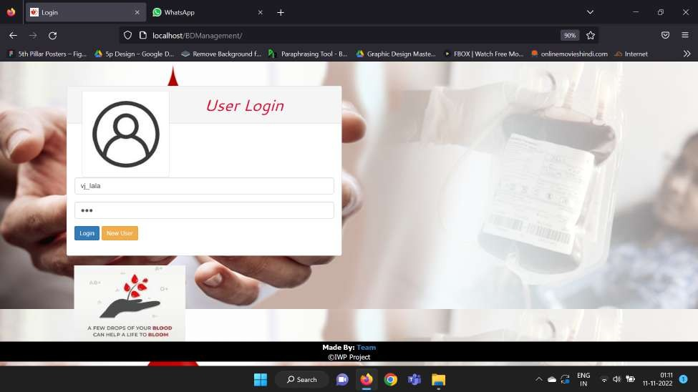

**Home Page**

#### (search for donor with blood group)

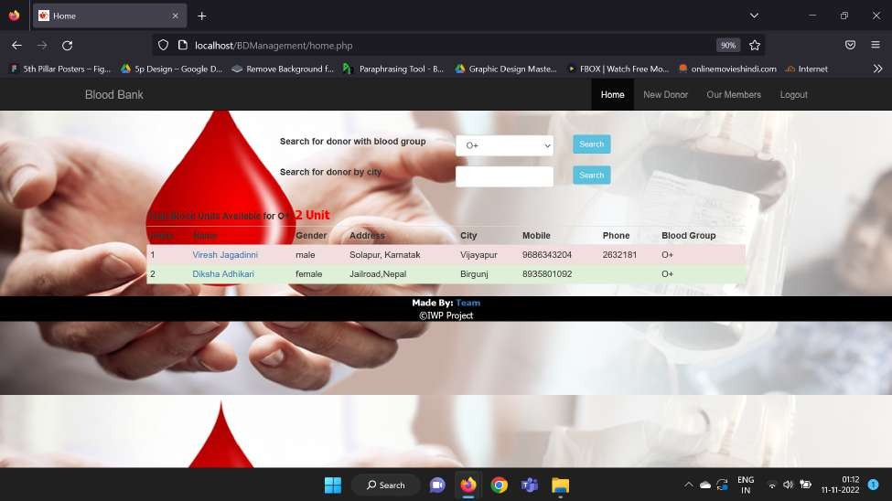

(search for donor by city)

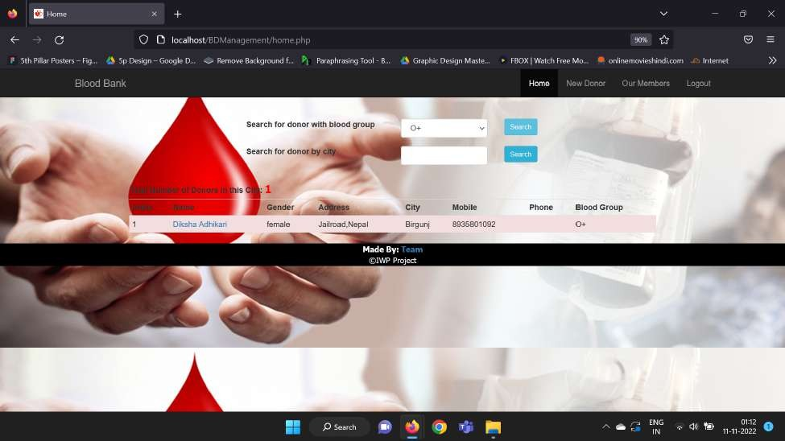

### New Donor

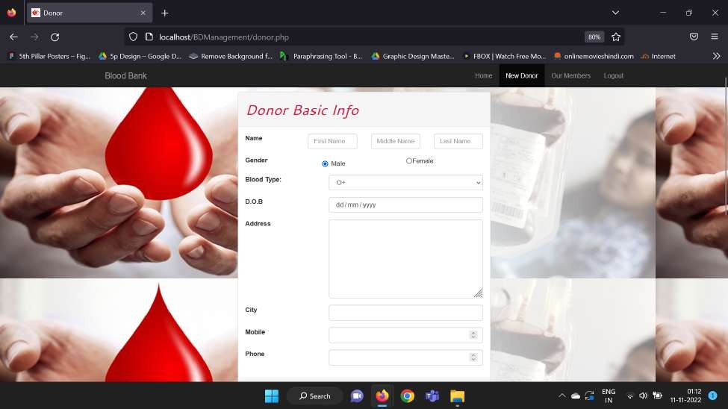

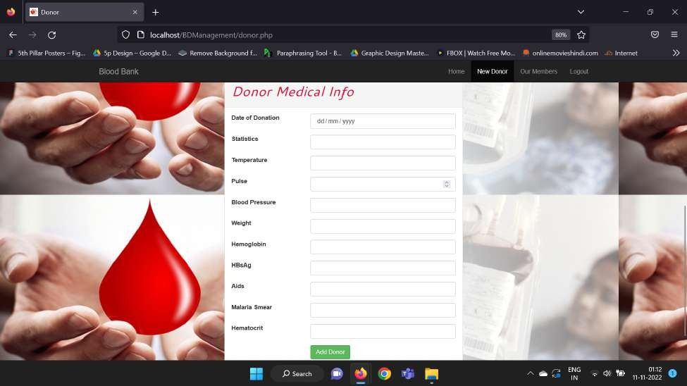

**Our Members list**

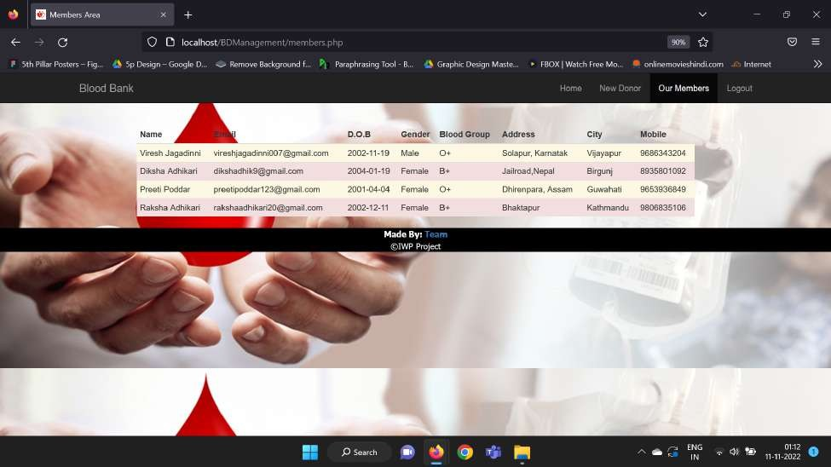

### Home For New User

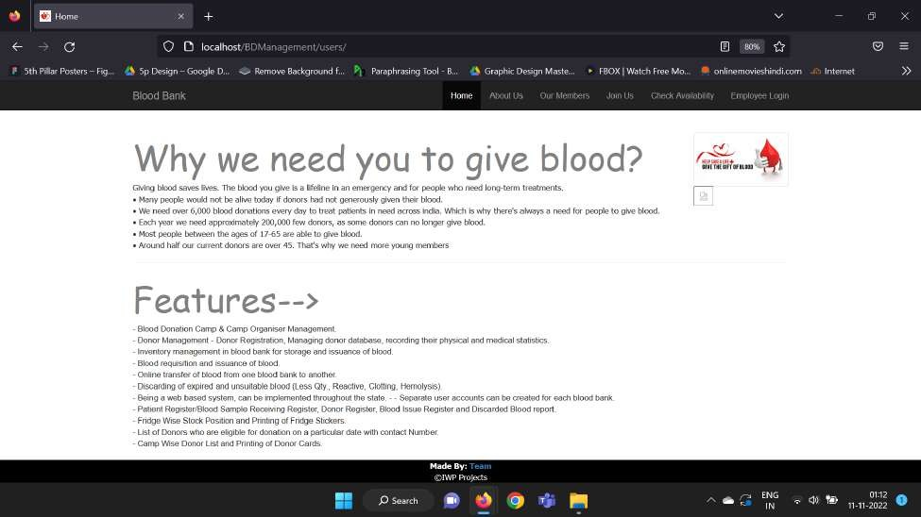

**About us**

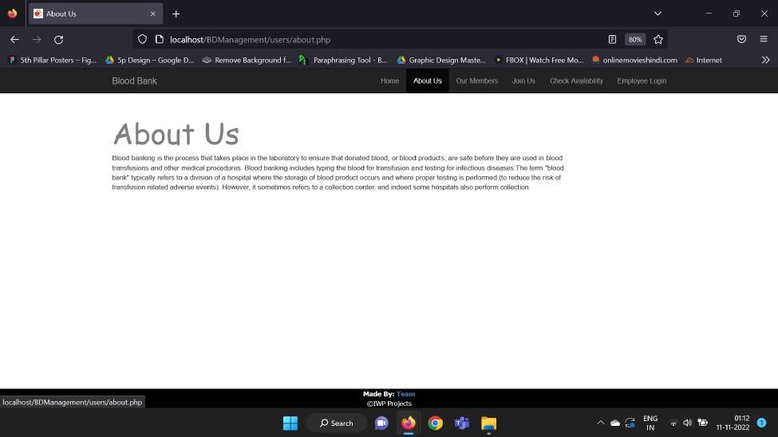

### Our members

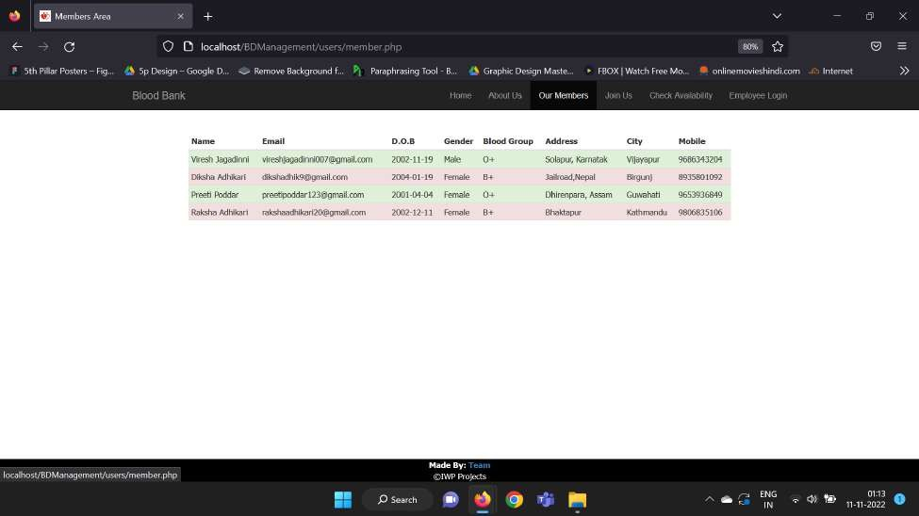

**Join Us**

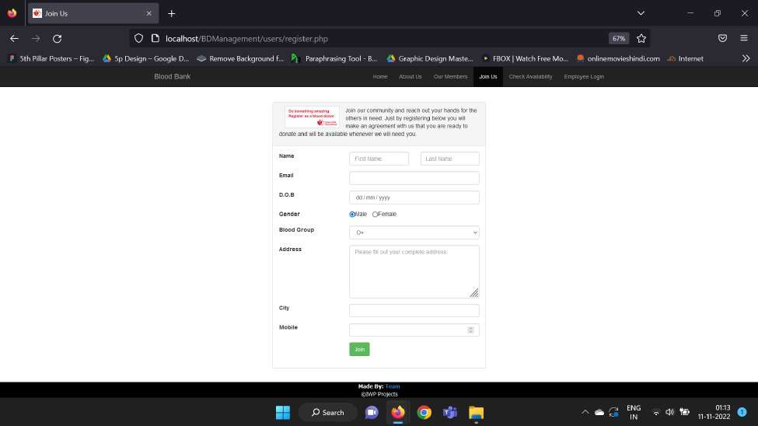

### Check Availability

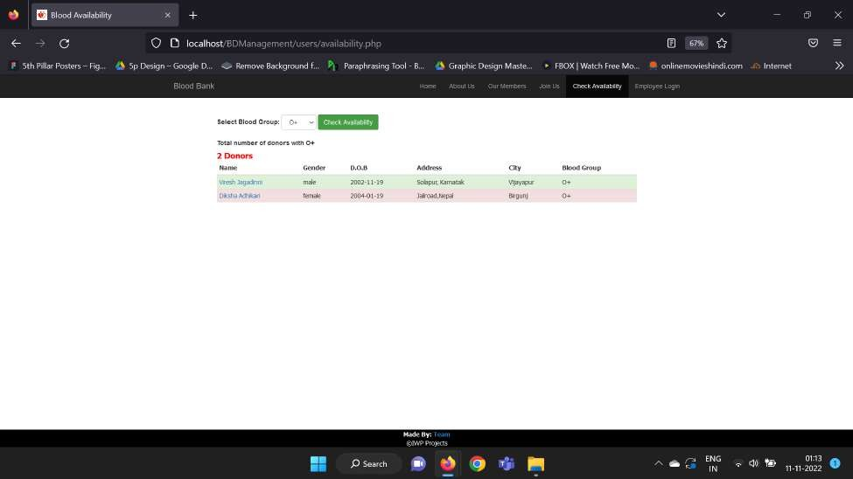

**Donors Database**

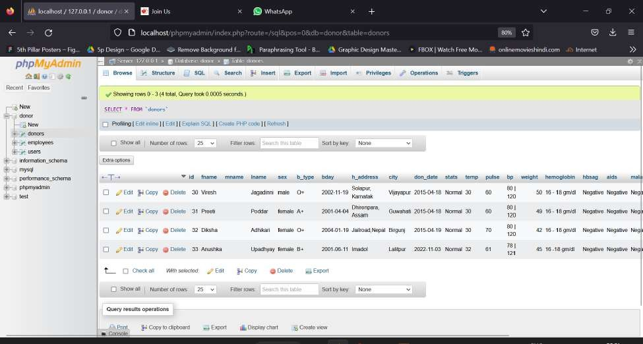

### Employee Database

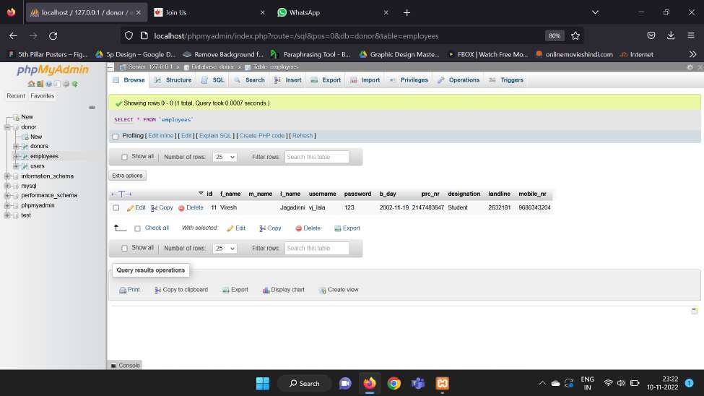

**Users Database**

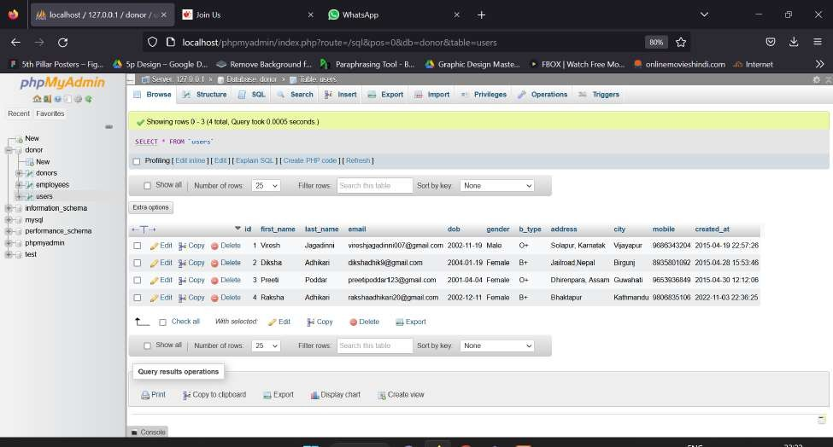

1. **References**
2. R. Kumar, S. Singh, and A. Ragavi, “Blood Bank Management System,” 2017. Accessed: Apr. 20, 2022. [Online].
3. A. Clemen Teena, A. Teena, K. Sankar, and S. Kannan, “A Study on Blood Bank Management,” Middle East Journal of Scientific Research, vol. 19, no. 8, pp. 1123–1126, 2014, doi: 10.5829/idosi.mejsr.2014.19.8.11202.
4. S. A. Chaudhari, S. S. Walekar, K. A. Ruparel, and V. M. Pandagale, “A Secure Cloud Computing Based Framework for the Blood bank,” IEEE Xplore, 2018. https://ieeexplore.ieee.org/abstract/document/8537 351 (accessed Apr. 18, 2022).
5. J. Akhtar, M. Alony, P. Scholar, and J. Akhtar Khan, “A New Concept of Blood Bank Management System using Cloud Computing for Rural Area (INDIA),” 2015. Accessed: Apr. 22, 2022. [Online]. Available: https://researchtrend.net/ijeece/ijet21/ijetnew/5%2 0JAVED%20AKHTAR%20KHAN.pdf
6. S. A. Chaudhari, S. S. Walekar, K. A. Ruparel, and V. M. Pandagale, “A Secure Cloud Computing Based Framework for the Blood bank,” IEEE Xplore, 2018. https://ieeexplore.ieee.org/abstract/document/8537 351 (accessed Apr. 26, 2022).
7. A. Sheth, S. S Bhosale, and H. Kadam, “(PDF) Research Paper on Cloud Computing,” ResearchGate, Apr. 2021. [https://www.researchgate.net/publication/3524777](http://www.researchgate.net/publication/3524777) 80_Research_Paper_on_Cloud_Computing (accessed Apr. 28, 2022).
8. K. Akkas, I. Jahan, A. Islam, and Shafa-At Parvez, “Blood Donation Management System,” American Journal of Engineering Research (AJER), vol. 4, no. 6, pp. 123–136, 2015, Accessed: Apr. 25, 2022. [Online]. Available: [https://www](http://www.ajer.org/papers/v4(06)/O0460123013).ajer[.org/papers/v4(06)/O0460123013](http://www.ajer.org/papers/v4(06)/O0460123013) 6.pdf
9. S. Sundaram, “Real-Time Blood Donor Management Using Dashboards Based on Data Mining Models,” 2011. Accessed: Apr. 27, 2022. [Online]. Available: [https://www.ijcsi.org/papers/IJCSI-8-5-2-159- 163.pdf](https://www.ijcsi.org/papers/IJCSI-8-5-2-159-%20163.pdf)
10. V. Kulshreshtha and Dr. S. Maheshwari, “Blood Bank Management Information System in India.” Accessed: Apr. 24, 2022. [Online]. Available: [https://www.ijera.com/papers/vol%201%20issue%](http://www.ijera.com/papers/vol%201%20issue%25) 202/012260263AF.pdf
11. G. Muddu Krishna; S. Nagaraju (2016), “Design and implementation of short

message service (SMS) based blood bank”, 2016 International Conference on Inventive Computation Technologies (ICICT)